**Table of Contents**

1. Navigation
   1. User (top) Bar
   2. Navigation Bar
2. Page Views
   1. Home
   2. About Us
   3. Contact Us
   4. Gallery
      1. Add a new Gallery
   5. Shop
   6. Inventory
      1. Item Categories
         1. Category View Page
      2. Item List
         1. Item
   7. User List
      1. View User
   8. Mailer
   9. Send new Email
   10. Change Headline
   11. Placed Orders
       1. View Order
   12. Shopping Cart
3. Using the Website
   1. Signing up and shopping
   2. Profile Management
   3. The Admin Account and Website Editing
   4. User management (Permissions, etc.)
   5. Inventory management (Items categories and Items)
   6. Using the Mailer
   7. Using the Headlines.

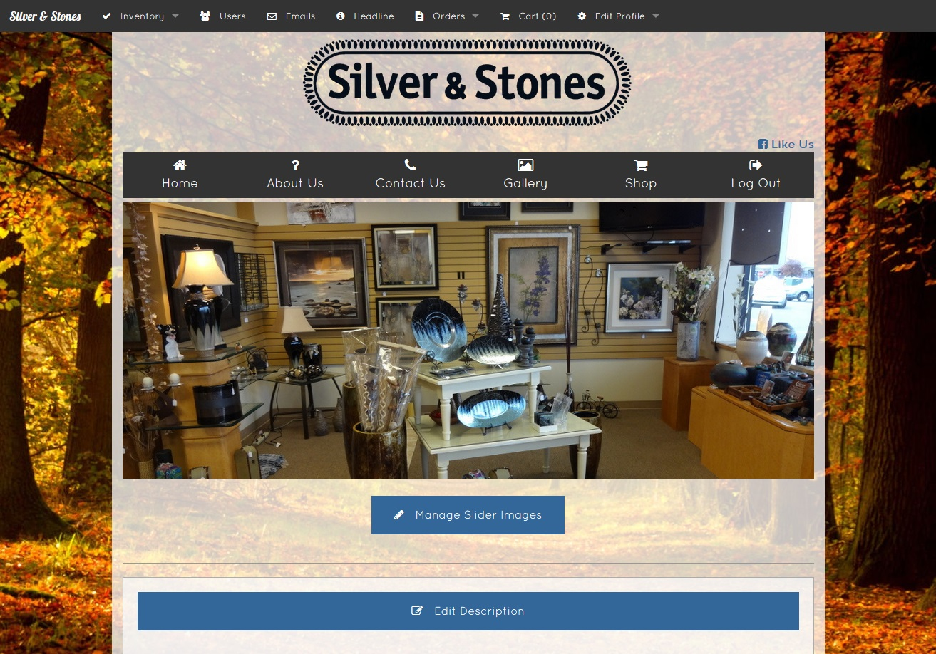

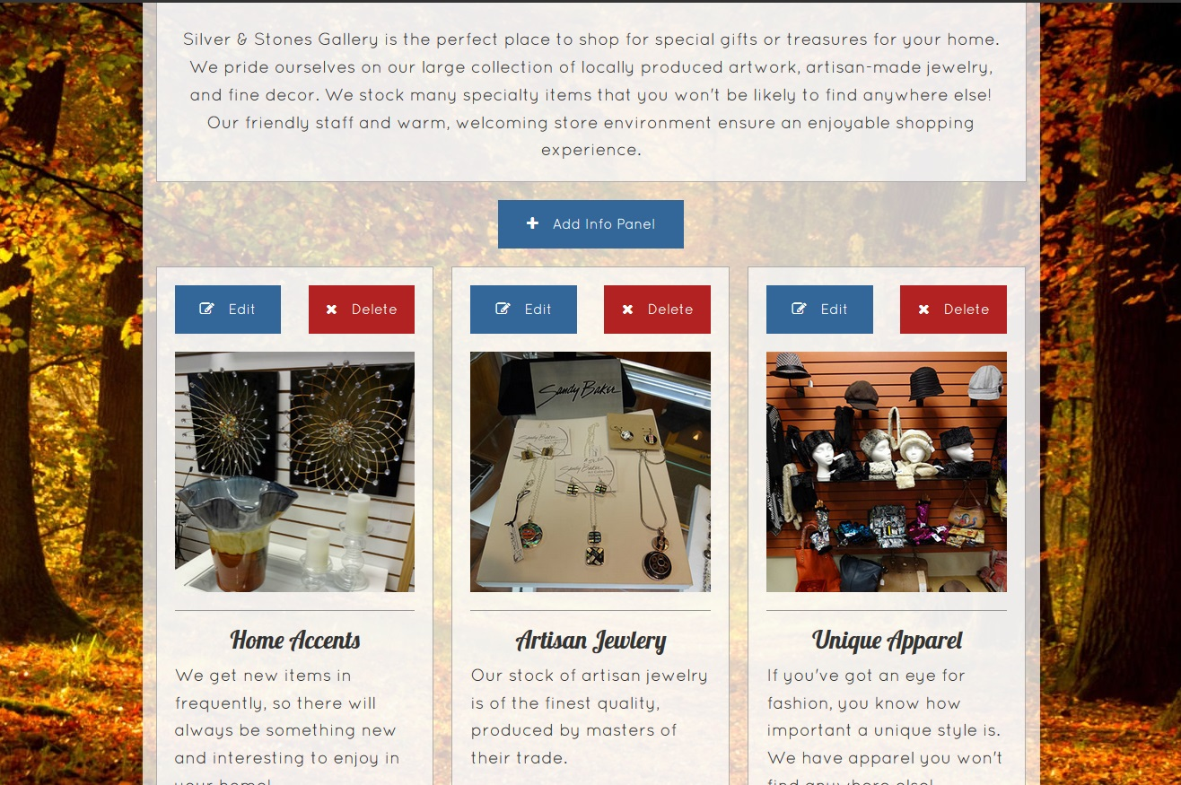

4

5

3

2

1

Home Page

This is the page that visitors will first see when browsing your web page.

1. Manage Slider Images

This button will allow you to change the pictures in the slideshow.

**See tutorial 3 for more detail on managing the slideshow.**

1. Edit Description

This button will allow you to edit the welcome text in the box beneath it.

1. Add Info Panel
2. Edit Info Panel
3. Delete Info Panel

The above three buttons will allow you to manage the info panels located below. **Edit** and **Delete** affect only the panel that contains the buttons, while **Add** will create a new one at the end.

**See tutorial 3 for more detail on adding panels.**

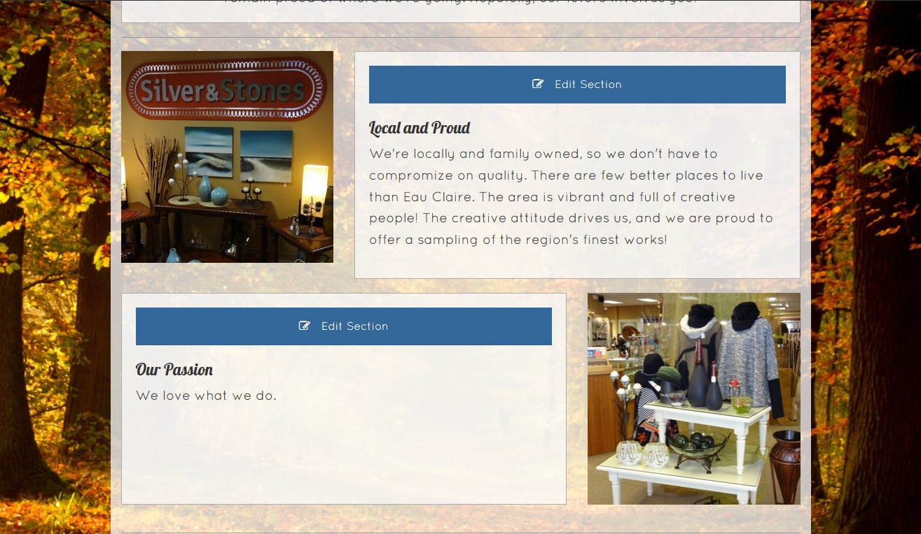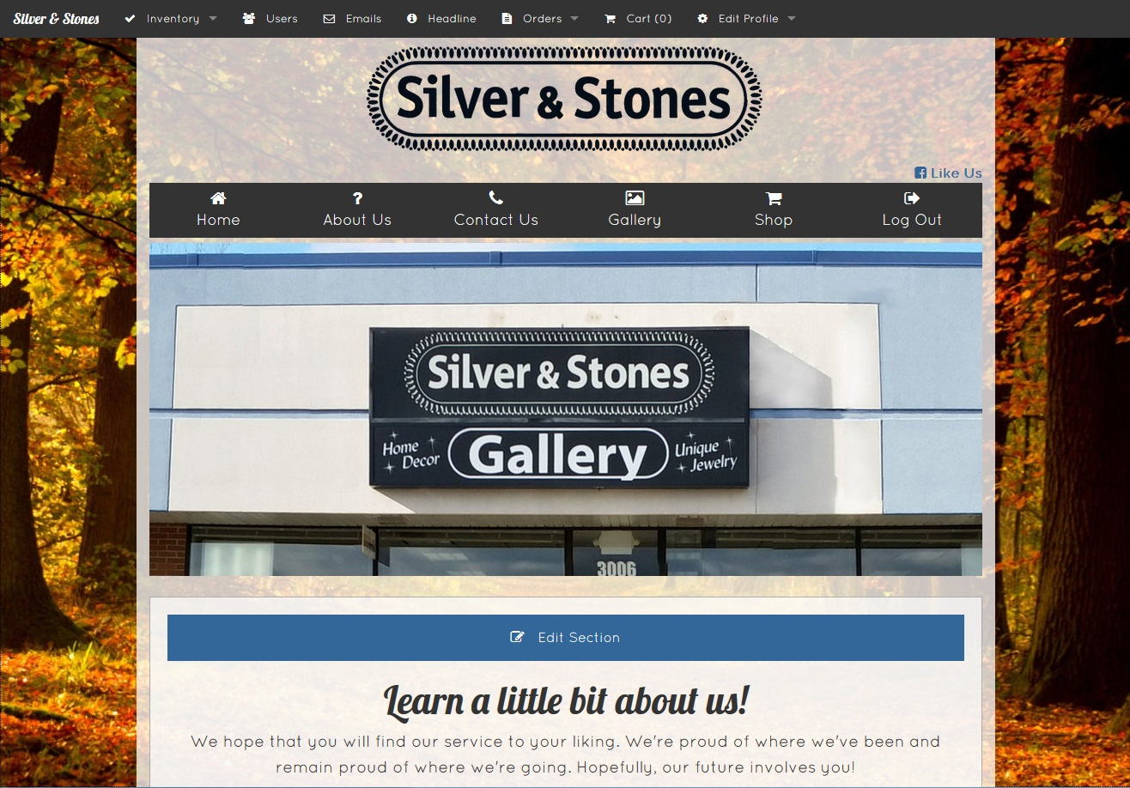

About Us Page

This page will allow you to tell your visitors a little bit about your store’s history as well as the quality they can expect from your goods and employees.

The arrows mark which of the sections will be edited by each button

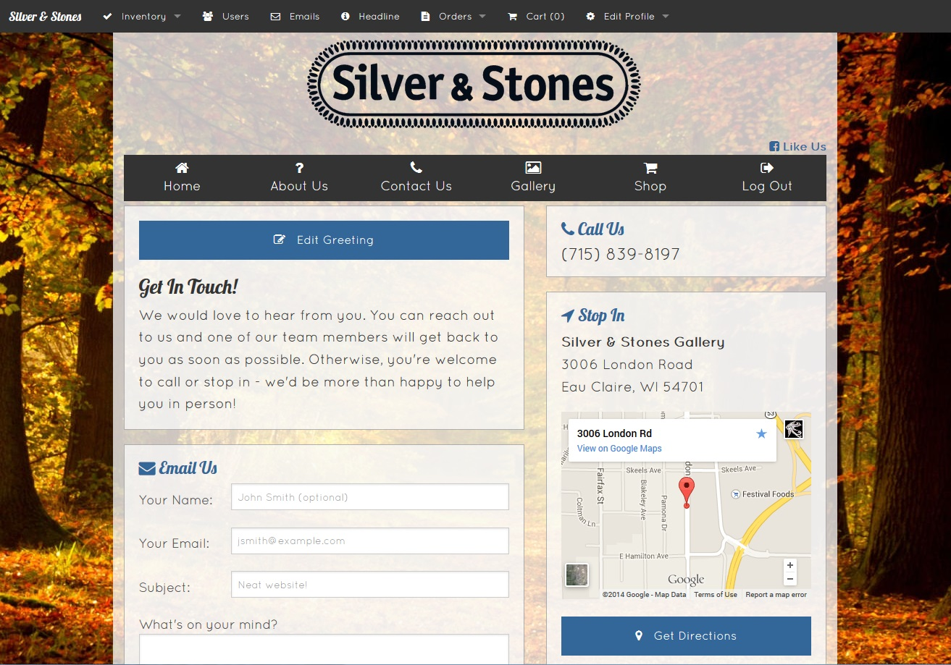

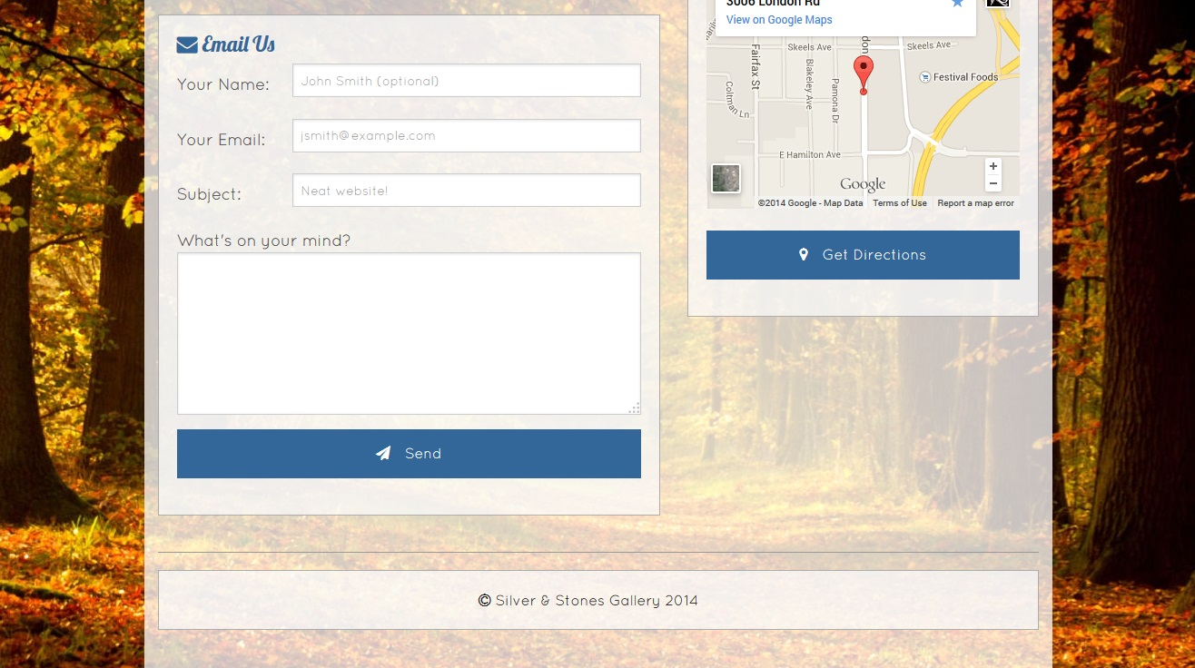

3

1

2

Contact Us Page

This page contains contact and location information for your store.

1. Greeting Box

This text field allows you to provide information with regards to how you would prefer to be contacted, or can left as a general greeting. If you want them to have specific information on hand when they contact you, this is the place to tell them!

1. Email Us

This field will allow users to send an email to you. No editing necessary—all emails will go right to the company email provided.

1. Stop In

This is a Google Maps link to the location of your store. If you move, you’ll want to be sure to update this location. **This will have to be done by someone familiar with the back end.**

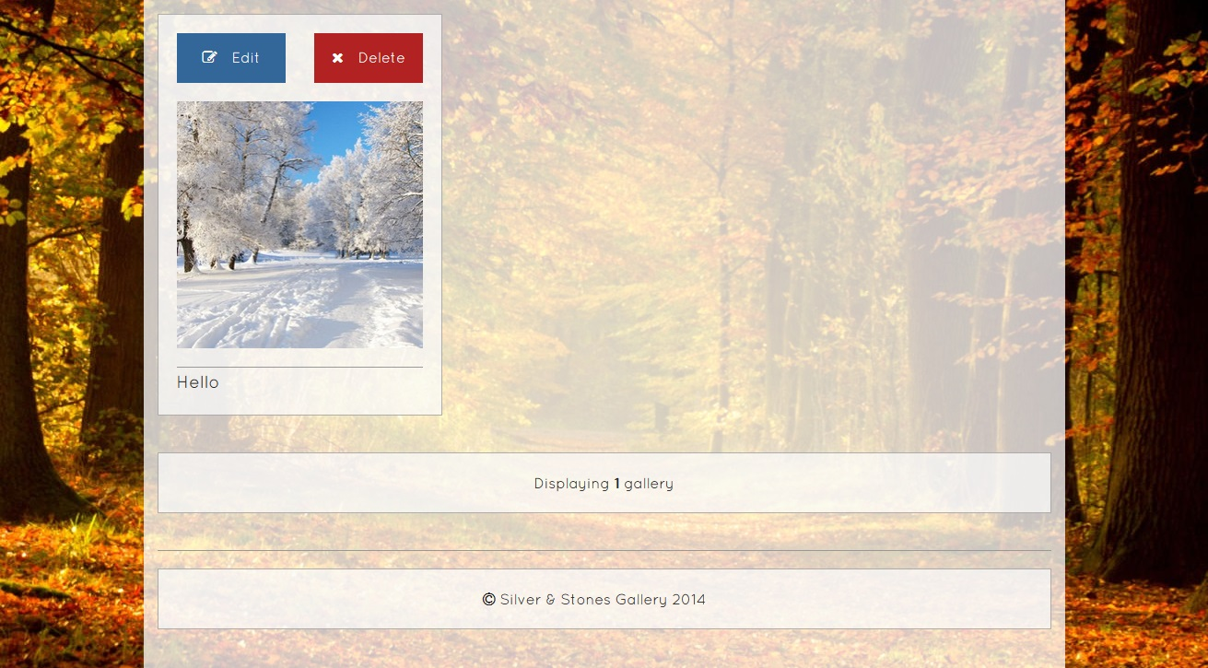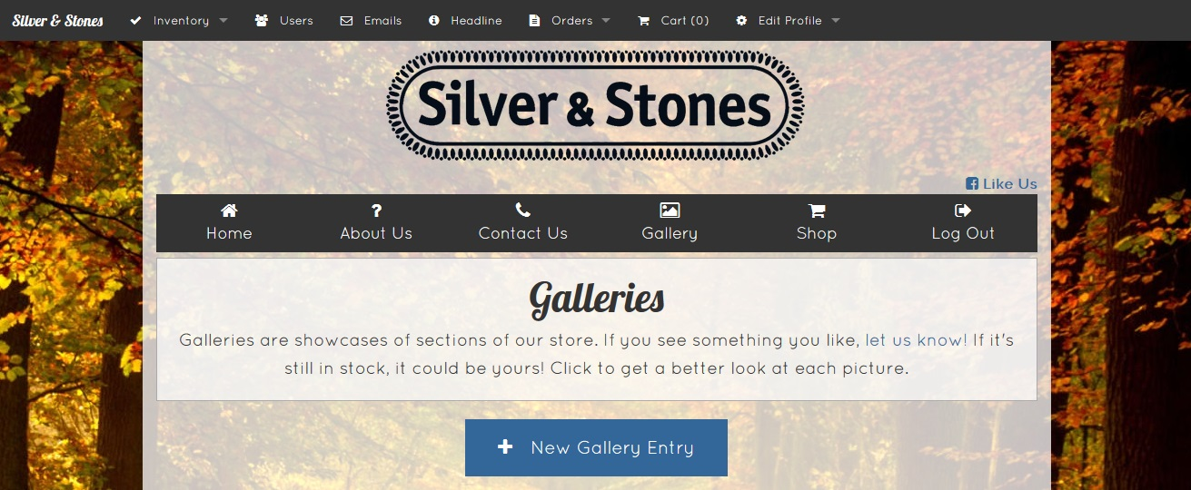Add Gallery Entry

3

2

1

This page will go over how to add a new gallery entry. **Because the format is similar for editing most fields, this page can help with figuring out how to edit other fields throughout the website.**

1. Description Box

Use this text field to add a brief description of what’s in the photo.

1. Picture

Click the Browse… button to choose a photo. This will open up a new window for you to search for your photo in.

1. Create Gallery

Submits your new entry to the list.

**See tutorial 3 for more information.**

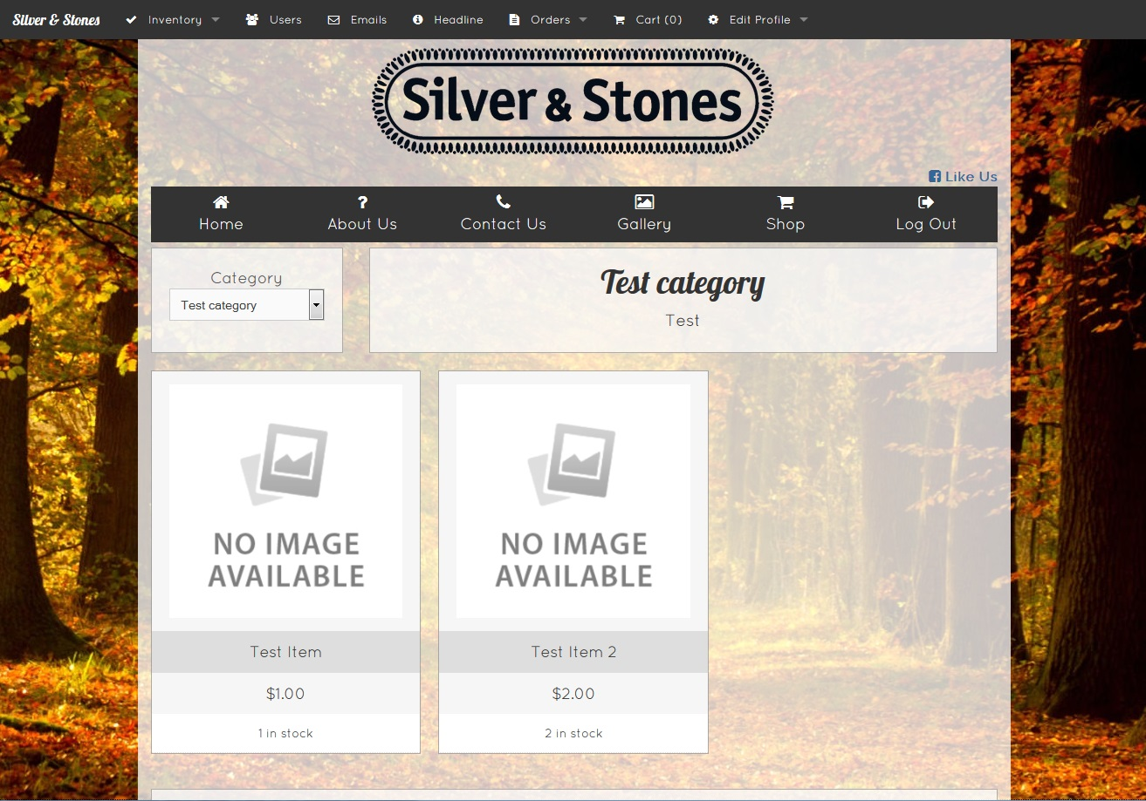

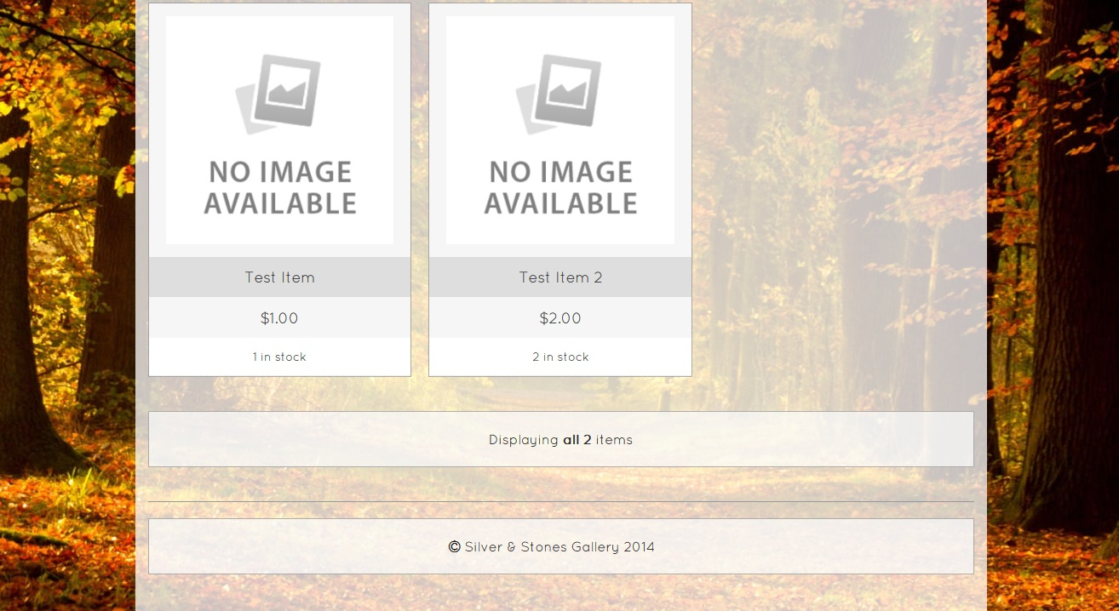

Item Page

This page provides more information on the item.

1. Quantity

This dropdown box is for selecting the quantity desired.

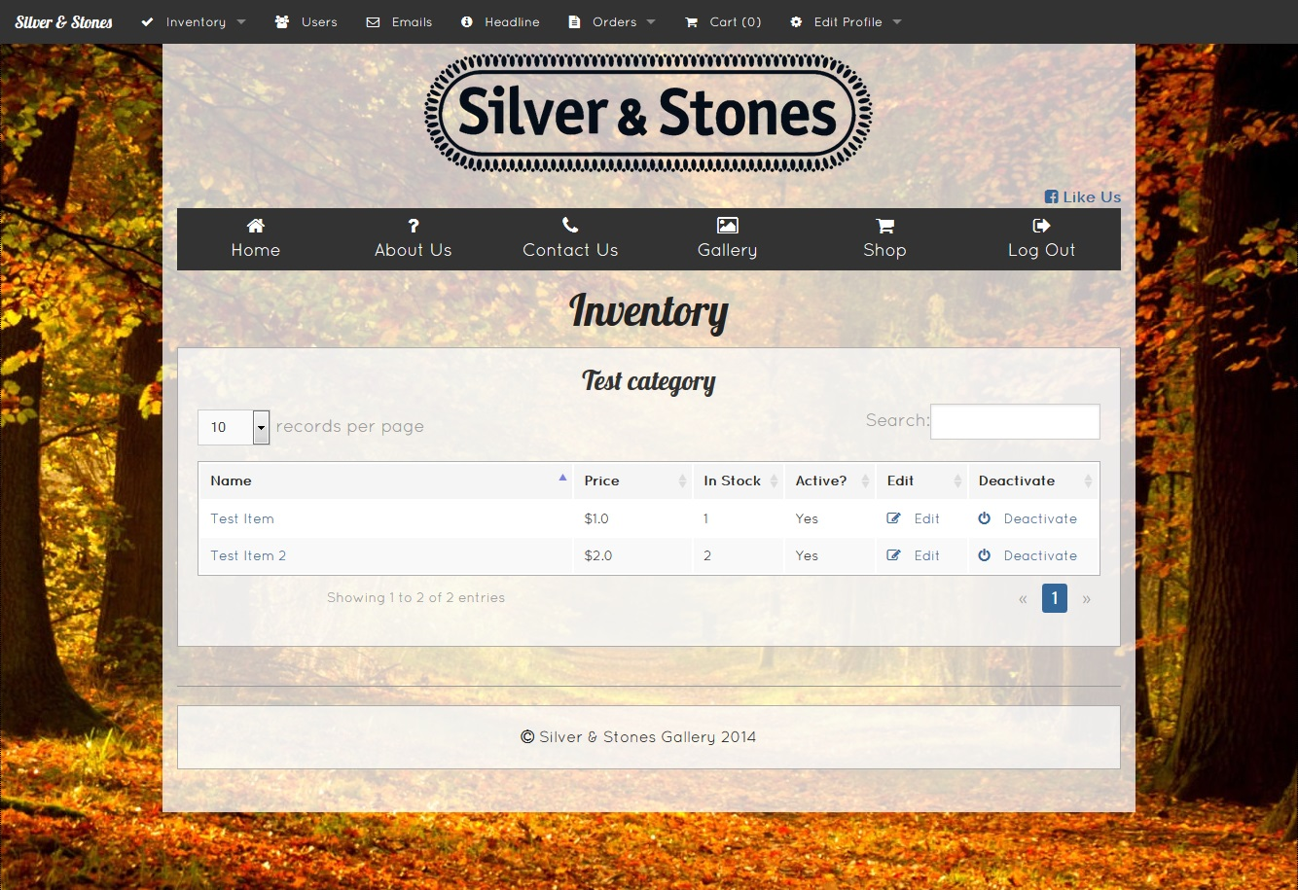

Inventory Page

This page will show all items currently listed on your website. Each category will have its own section and items contained.

1. Item

Clicking the name of the item will take you to the item’s page.

1. Edit

Clicking this link will allow you to edit the details for this item. **See tutorial 5 for more information.**

1. Deactivate

Clicking this button will hide the item from view of the users, but keep it on the website to be updated later.

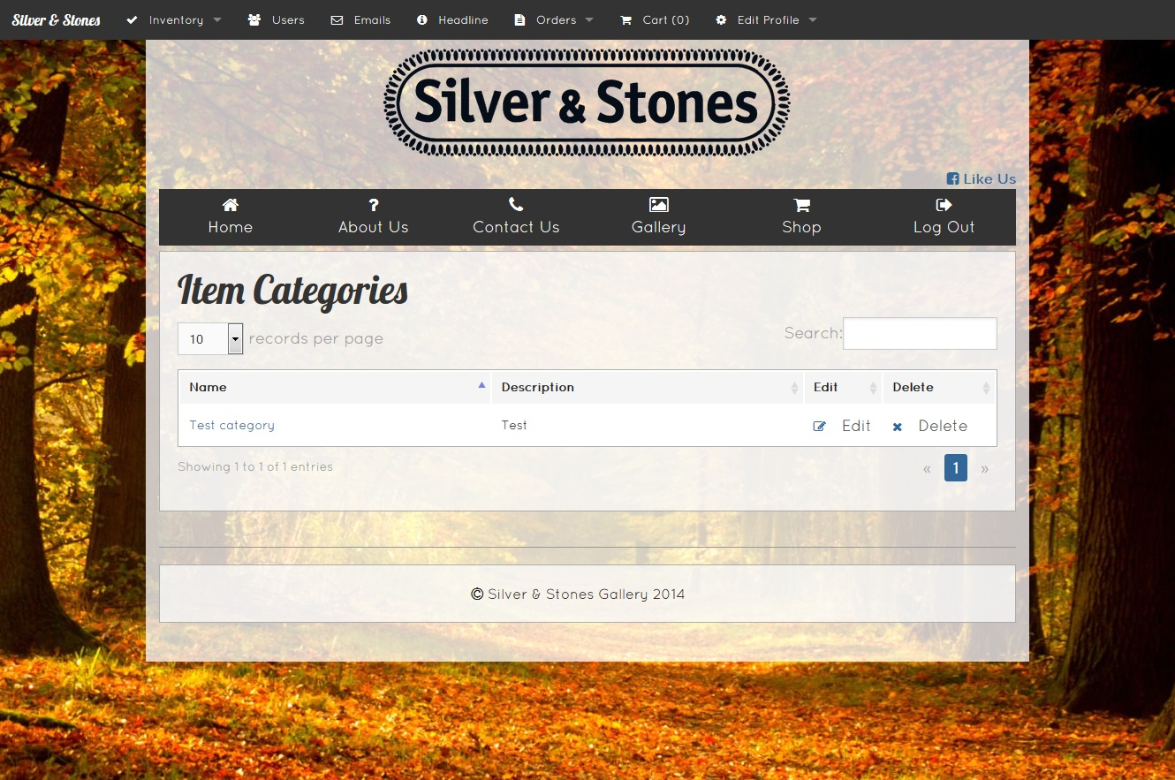

Category View Page

This page will show which items are contained in a specific category

1. Item

Clicking the name of the item will take you to the view page for that item.

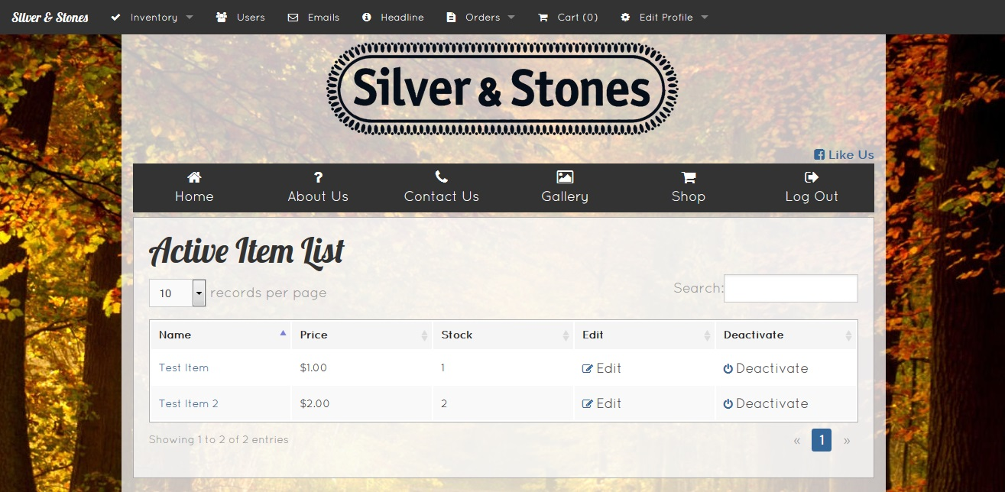

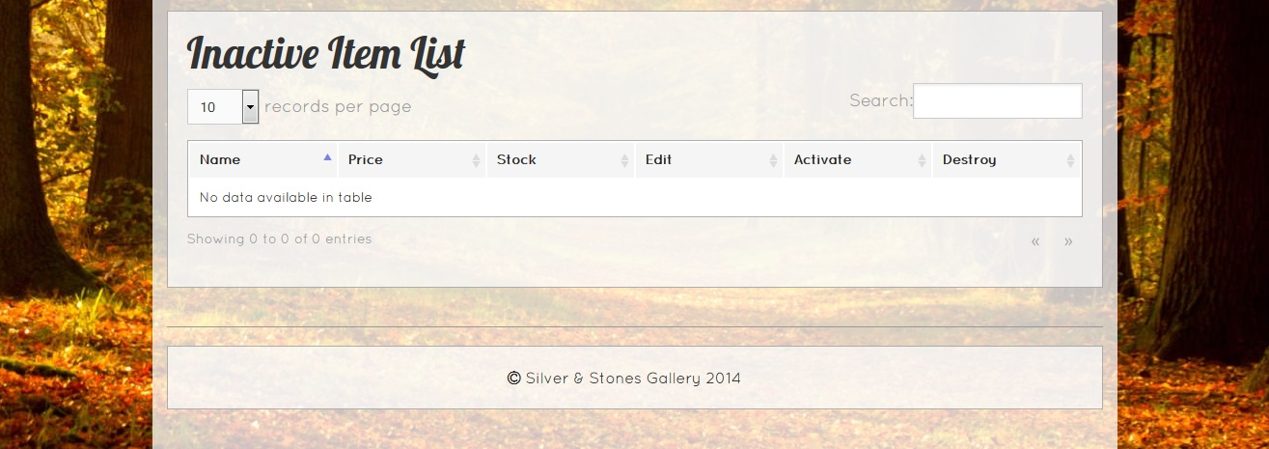

Item List

This page shows all of the items in your database, separating them by items marked as Active and ones marked as Inactive

1. Active Item List

Items in this box are currently active and viewable on the website by all users.

1. Item

Clicking on the name of the item will bring you to a page for that item

1. Edit

Clicking this will allow you to edit that item’s details

1. Deactivate

Clicking this will move the item to the Inactive Item List below. The details will stay, but it won’t be viewable by customers until reactivated.

1. Inactive Item List

Items listed in this box are currently inactive. Customers will not see these items.

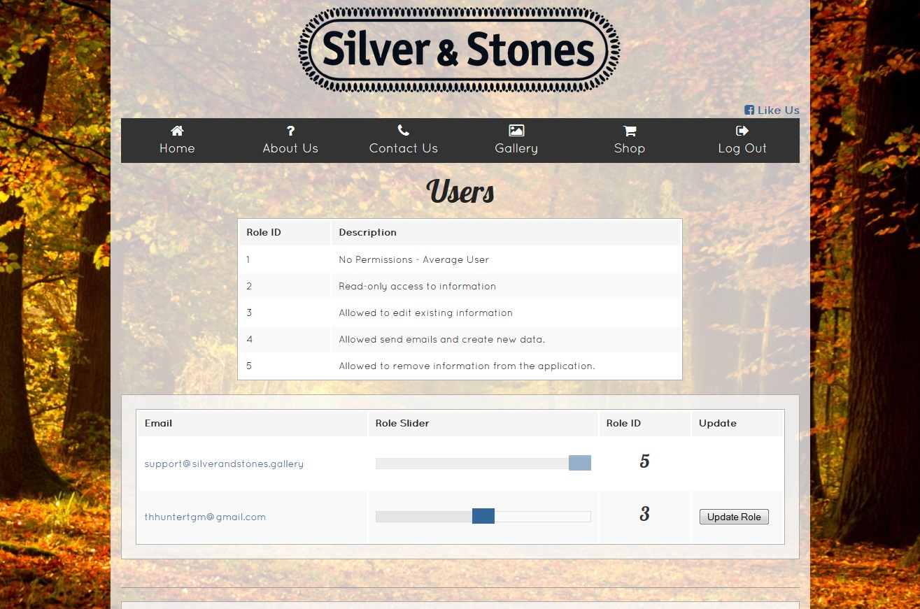

User View Page

This page provides user details necessary for contact. It is not viewable publically without the proper permission level.

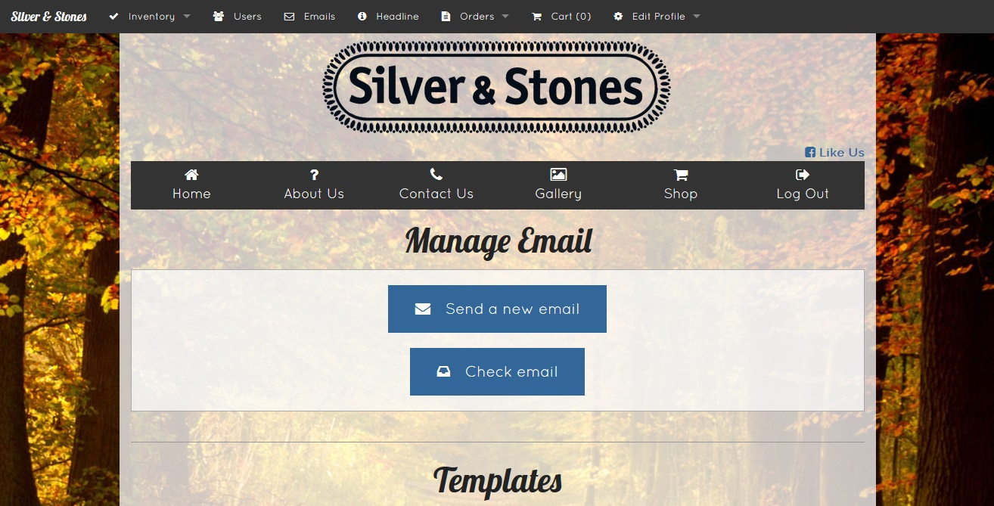

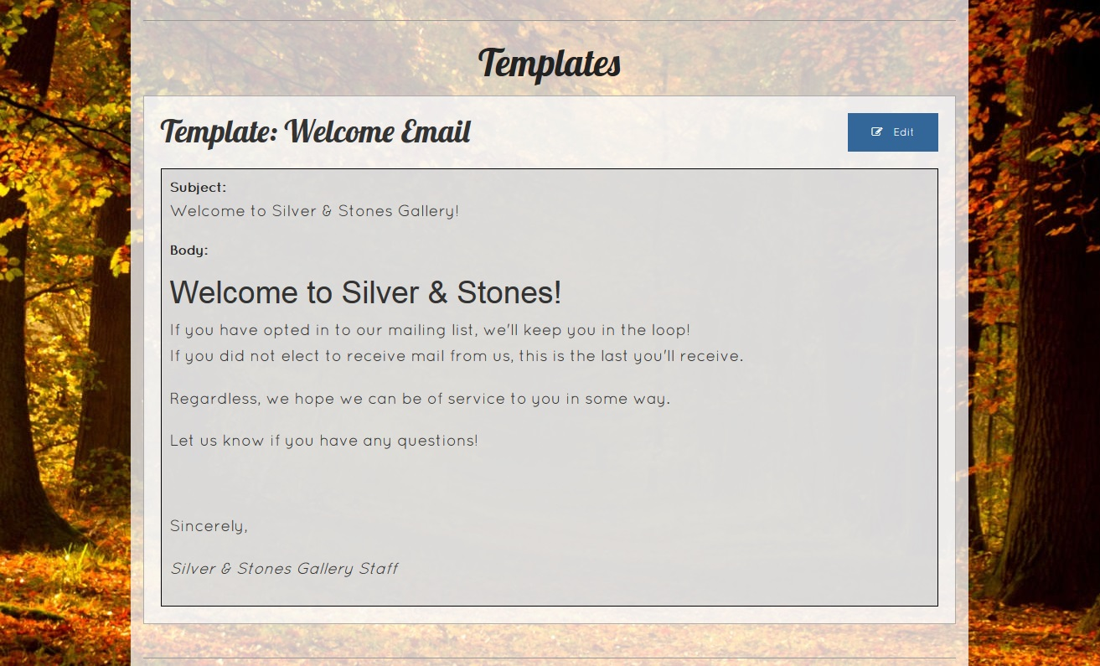

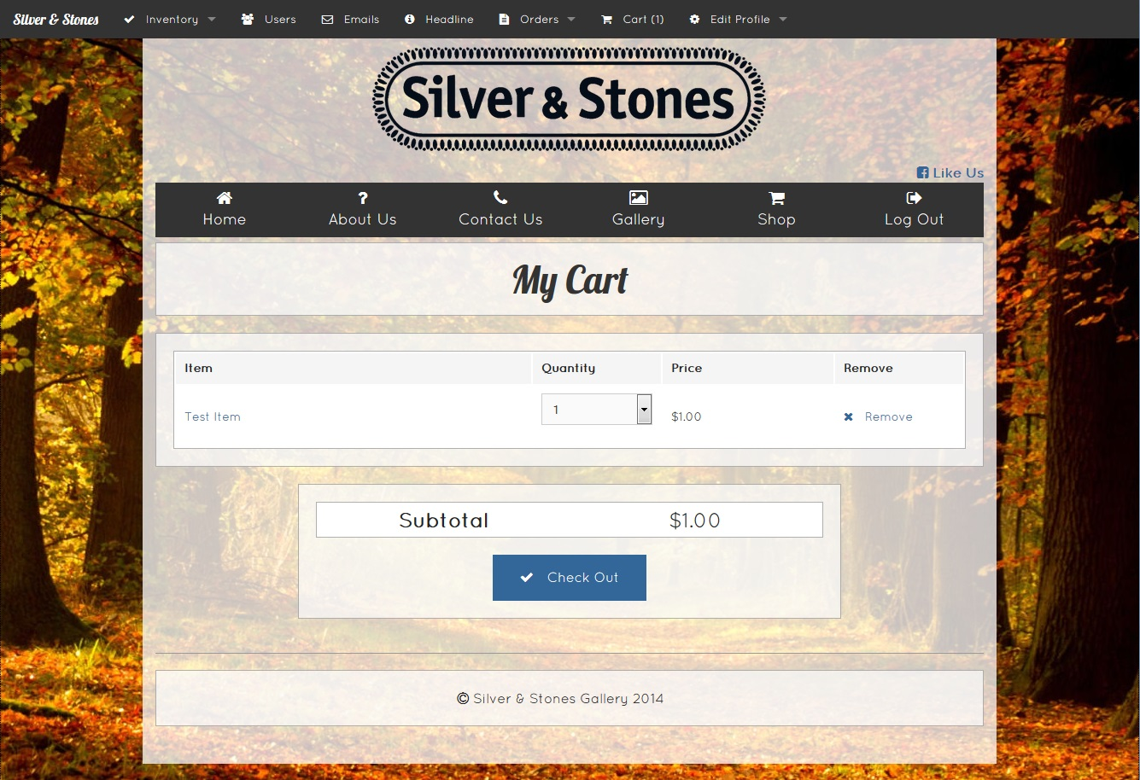

Send Email page

This page is where you can create an email to be sent to all subscribed users

1. Subject Field

Enter the subject for the email here

1. Body

This is the body of the email. The buttons above allow for various formatting options for your message.

1. Send

Sends the email. Double check the message before sending!

**See tutorial 6 for more information regarding using the mailer**

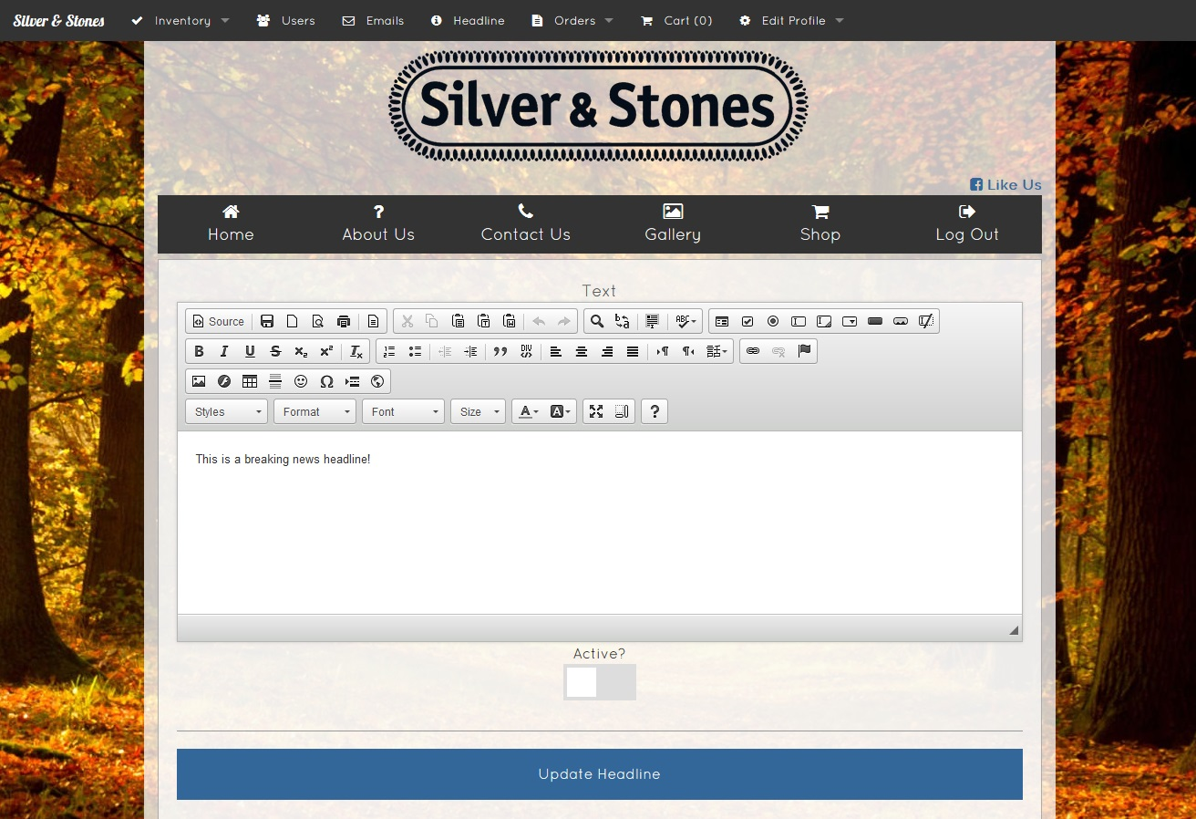

Headline Page

This page allows you to edit the notice message that appears above the home page while active. Useful for important updates or sale notifications.

1. Body

This contains the message you want to be displayed

1. Toggle Active

Clicking this button with switch whether the headline is currently being displayed or not. If it’s grey, it’s off. If it’s blue, it’s on and being displayed.

1. Update

Click this to finalize your updates to the headline

**See tutorial 7 for more information for getting to and updating the headline.**

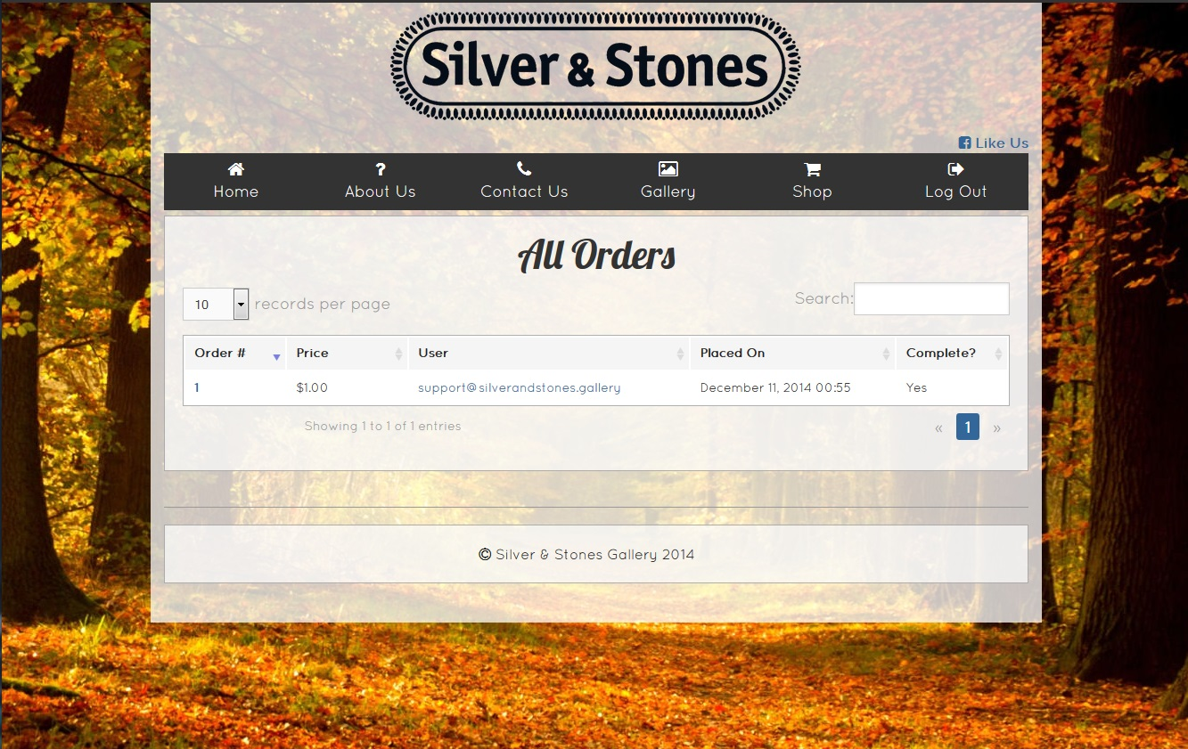

Gallery Page

This page allows you to post general pictures of your store, providing customers the ability to browse the store as they would in person.

1. New Gallery Entry

This button will allow you to add a new photo to the gallery. **See tutorial 3 for more information.**

1. Edit Gallery

This button will allow you to edit a singular gallery entry. **See tutorial 3 for more information.**

1. Delete Gallery

This button will remove a gallery entry

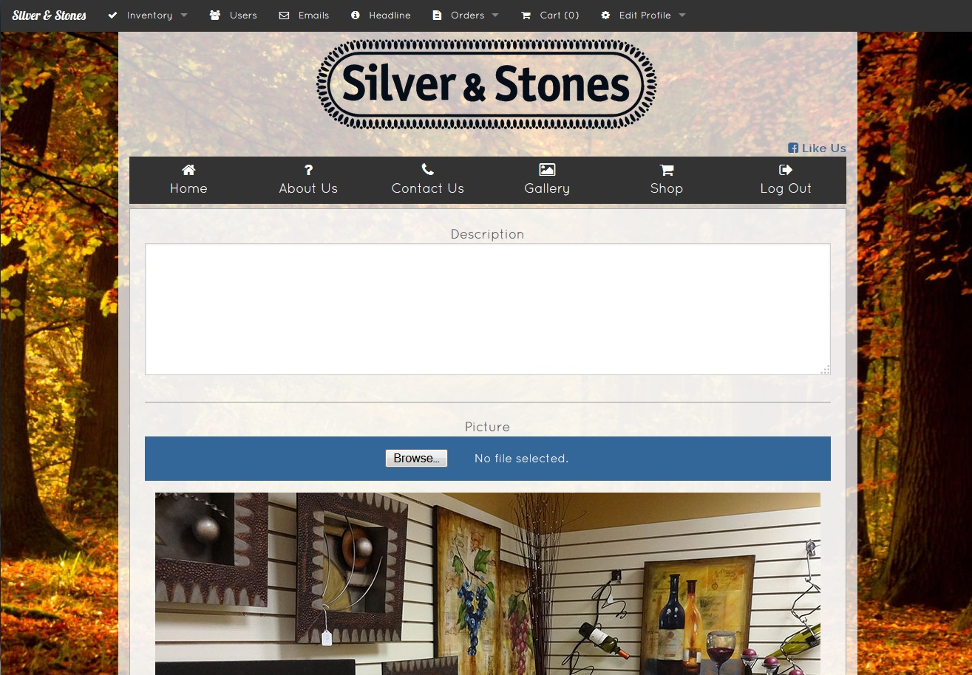

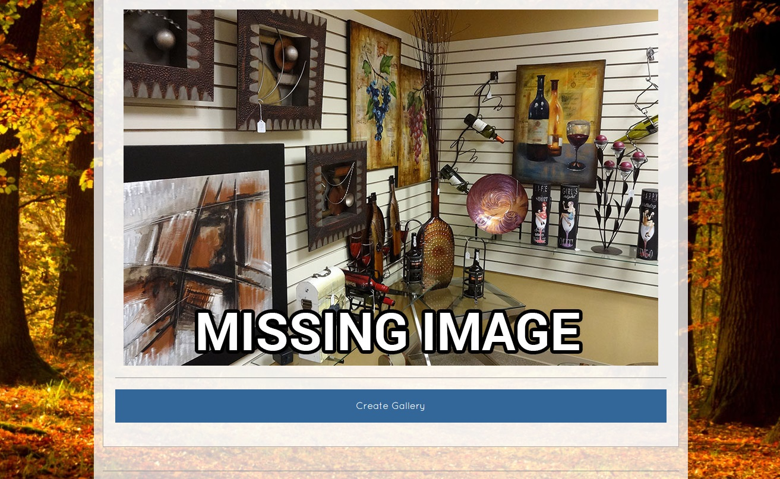

Shop Page

This page is where users can browse your items and begin selecting goods for purchase.

1. Category Selection

This drop down box is used to select which category of items will be shown.

1. Item Selection

Clicking one of these boxes will take the user to the **Item Page** for that item.

**See tutorial 5 for more information on the inventory system.**

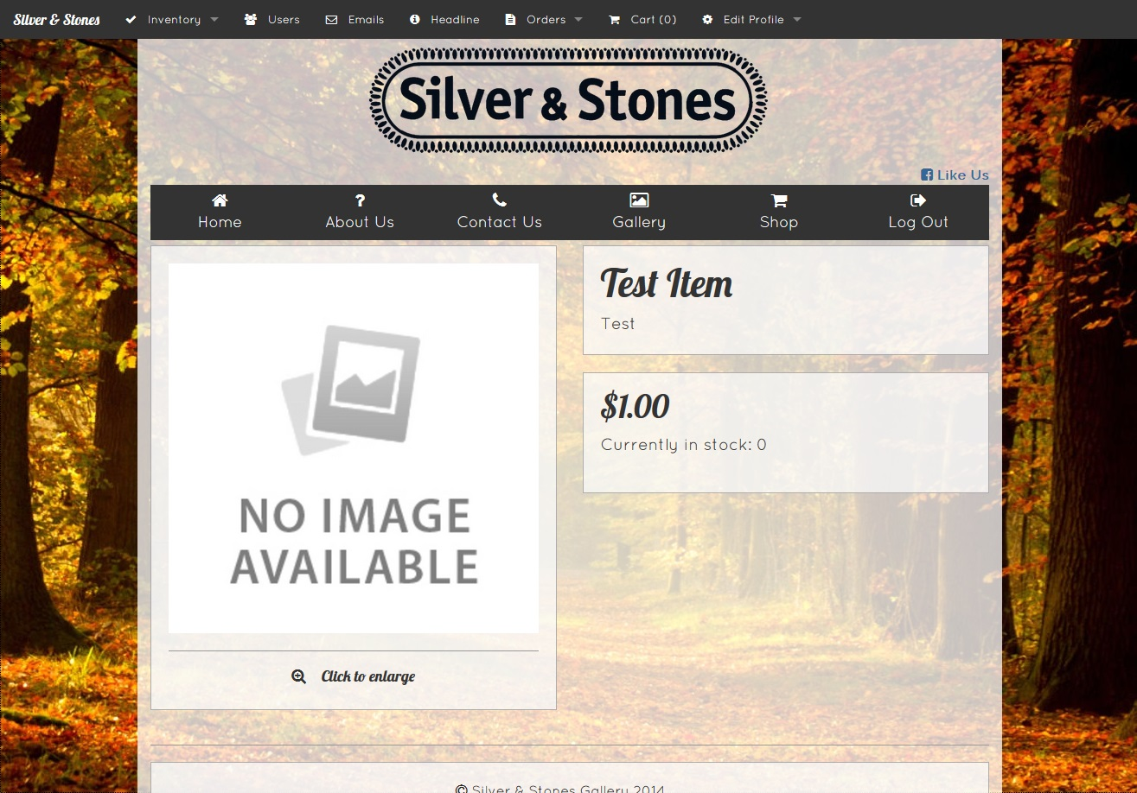

Category List Page

This page is a list of all current item categories you have available.

1. Category Name

Clicking the name of the category will bring you to the view page for that category.

1. Edit

Clicking Edit will allow you to change the name and description for the category

1. Delete

Remove the category

**See tutorial 5 for more information on inventory management**

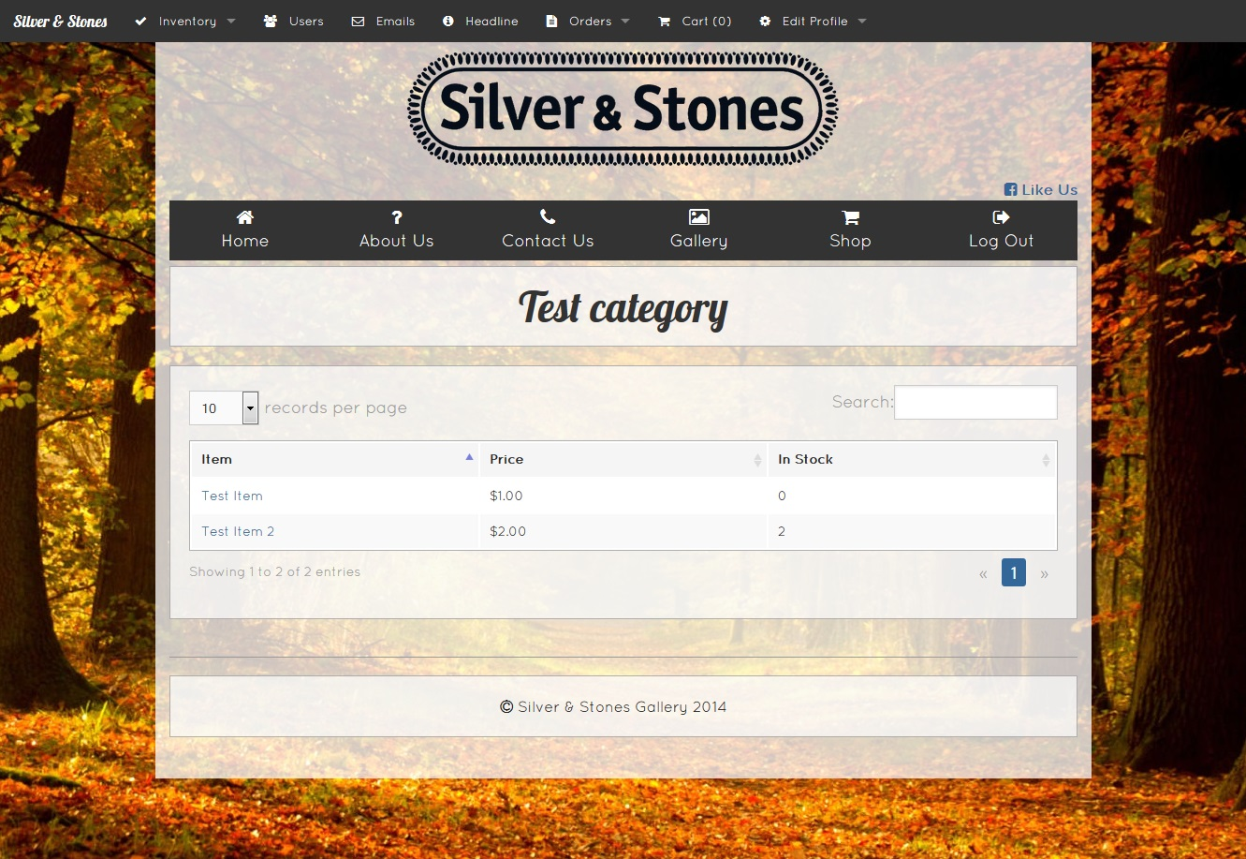

Users Page

On this page, you can view all of the users that have registered accounts on the website and edit their permissions. The higher levels of permissions allow for more control over the website. **Note that a user cannot promote someone further than his or her own permission level** (For example, if my permission level is 3, I cannot promote someone to level 5).

The slider for each user can be adjusted by holding click and dragging it left or right. Explanations for each level are:

1. This is your regular user, and can only access the non-private information pages as well as the shop.
2. This user can view some slightly more private information, such as the list of orders and the list of users (this page), but cannot edit, add, or delete anything.
3. This user can now edit existing information, but cannot remove or add anything from the website. Able to manage things to an extent but won’t be breaking everything.
4. This user can now add things and also has **access to the mailer.** As the mailer sends out an email to every user that is currently subscribed, it is important to be careful with how many people are at this permission level or higher.
5. This user has full permissions on the website

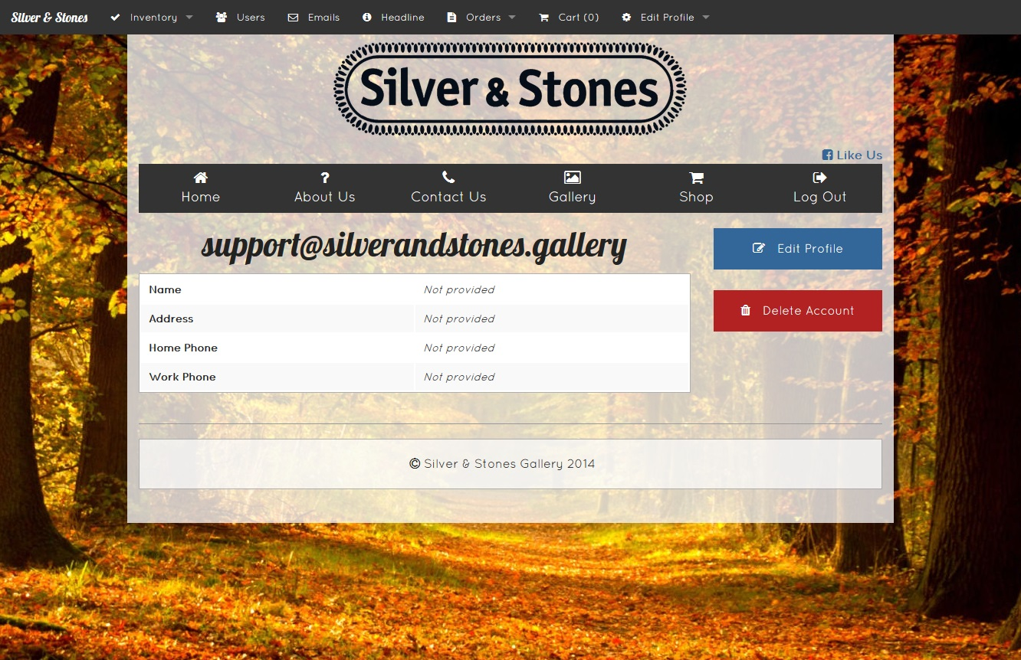

Mailer Page

This page is an overview of what you’ll need to start using the mailer. It is only viewable with the proper permission level.

1. Send a new Email

This will take you to the send form that allows you to send an email to all currently subscribed users.

1. Check Email

This will take you to a separate web page that will allow you to check the company email inbox

1. Edit Template

This will allow you to edit the message that users receive upon registering for the website.

**See tutorial 6 for more information on how to use the mailer.**

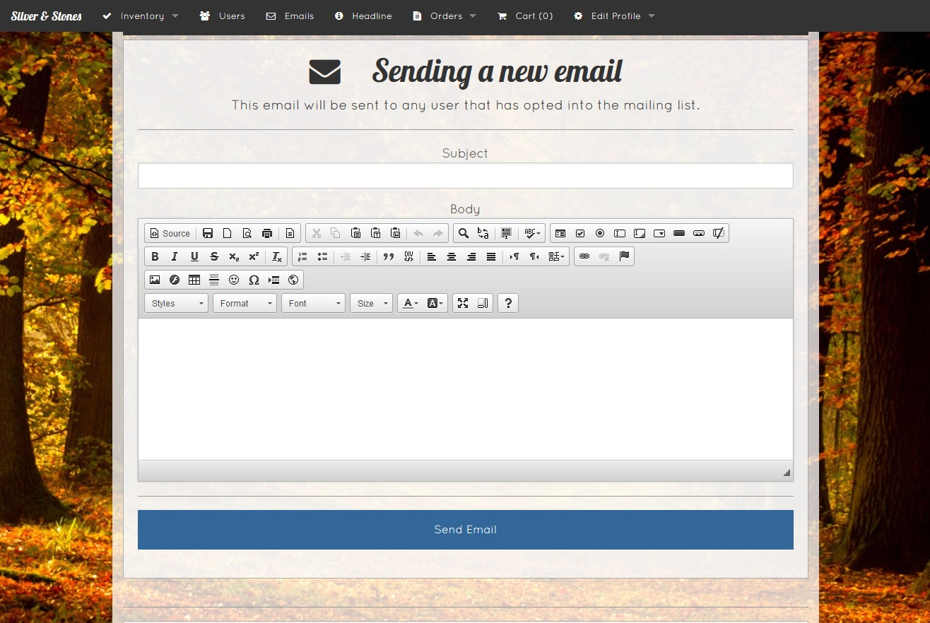

Orders List Page

This page will list all of the current orders placed through your website.

**Check this page frequently!**

1. Order

Clicking the order number will take you to a page with more in-depth information on the order

1. User

Clicking on the email will take you to a page with more in-depth information on the user

1. Complete

This field states whether or not an order has been processed yet. **Any orders that have not yet been processed should be handled by an employee as soon as possible!**

